3ro Medio
Francisco Contreras
Idioma Extranjero Ingles
franciscocontreras@colegiosanfelix.cl
GUÍA DE APRENDIZAJE INGLES N° 4
Nombre: |  | Fecha Entrega: | 05/06/2020

OBJETIVOS DE APRENDIZAJES
- Producir y comprender con fluidez textos orales y escritos breves y claros en situaciones comunicativas que involucren otras visiones de mundo y la propia, con el fin de interactuar y tomar conciencia de su propia identidad.

ITEM I: THE RESUME
What is a resumé?
Description of your education, qualifications, previous jobs and sometimes also your personal interests, which you send to an employer when you are trying to get a job; also known as curriculum vitae or CV.
There are many different ways to create a resumé, but most CV answer to one of the following types:

- Chronological Resumé: are the most commonly used format. They list work history in chronological order, starting with your most recent job down to your earliest. This resume is preferred by most employers because it provides a quick view of work history, with most recent positions up front.
- Functional Resumé: unlike chronological resumes, functional resumes focus on your skills and experience first. This type of resume de-emphasizes the dates in which you have worked. Employment history is secondary, and is listed under the details of your skills.
- Combination Resumé: combination resumes let you detail both your skills and experience, while also backing this up with a chronological listing of work history. Flexible in nature, the combination resume lets you tailor to the prospective job opening and tell hiring managers a story.
- Targeted Resumé: targeted resumes are customized in detail to the prospective job you are seeking. Everything from your objective, your qualifications to educational experience mirrors the job requirements.

It is important to understand the job requirements in order to create the proper resumé, in other words, you need to know what the employer is searching to write the right CV for that job, for instance, depending on the job, you can choose between chronological, functional, combination or targeted formats.

How do you find out about job requirements?

As we covered in the first part of our remote work, you can find information about the job looking at the different job classifieds available in the web and newspapers. Theses classifieds contain the most relevant information you need to know about a job.
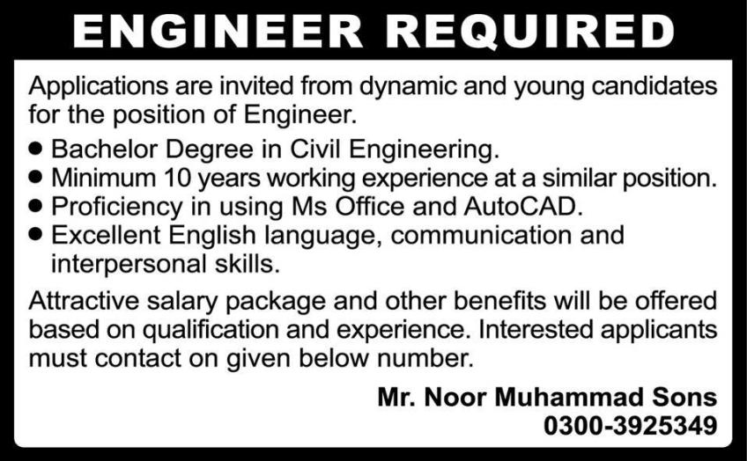
As you can see from this job classified, the company is looking for young engineers with a B.A. in Civil Engineering, with at least 10 years of work experience (emphasis on this), and certain qualifications such as using Ms Office, AutoCAD and excellent English communicative skills. For this job, a chronological CV would be a good choice.
ITEM 2: CONTEXTUALIZING.
In this worksheet we will focus on chronological and functional resumés as they are the most frequent and useful formats, especially as we need to focus on work experience or specific work-related skills to write our resumé.

- Chronological resumés common format is:
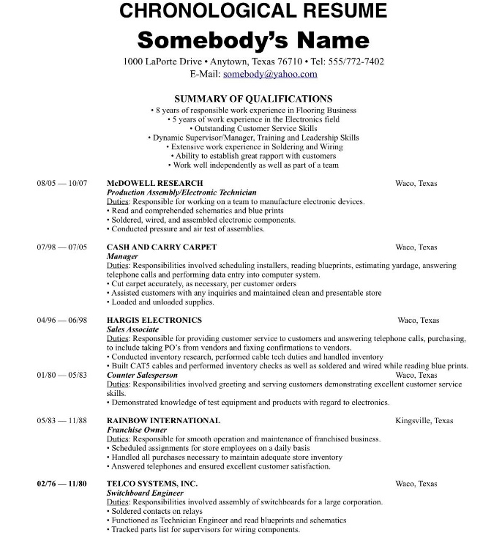
In this example, you can see that personal information and qualifications are not the most important aspects of this resumé.
Instead the work experience is given more importance, providing and highlighting information such as:
- most recent to oldest job
- detailing the time where the person worked (month and year)
- the company and position
- country and city
- the responsibilities in the company.

- Functional CV common format is:

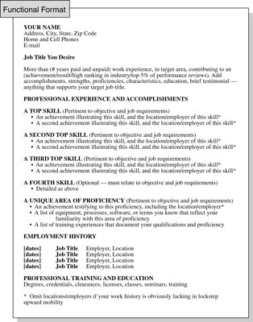

On the other hand, functional resumés are written containing and detailing in a complete and different way.

First it details your personal information briefly, then a brief paragraph detailing your job experience. Final it lists your top qualifications / skills, providing a brief description about it.

In the bottom part, you can write you work experience history briefly. Using the format date, job title, employer and location.

You can use Microsoft words template to access to this formats or download similar formats at https://templates.office.com/en-us/resume-templates
ITEM 3: ACTIVITY.
Creating a resumé / CV

You are going to choose one of the 4 classified and create a resumé that suits the information provided on the job offer. You have to decide whether to use the chronological or functional format depending on the requirement for the job, remember to use formal vocabulary, you can use your previous work as reference.

 | 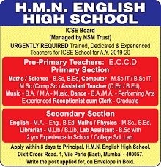
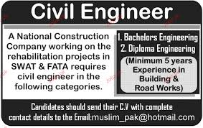 | 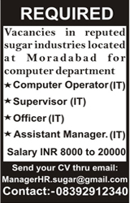

CONSIDERATION:

- Choose 1 out of the 4 job ads to create you resumé.
- Use chronological or functional formats only.
- Use the job requirements to create the resumé.
- You can create, adapt or extract information to fulfil the task.
- Use formal vocabulary.
- Use Word’s templates to write your resumé
- Provide all necessary information.
- You can copy the CV formats on page 2 from this worksheet.
- Write in English and English only.
- Read this worksheet and ask questions about it in our meeting by Wednesday 27th
- Watch the video explaining how to use Words templates on laptops and mobile phones (available since Friday 29th)

ITEM 4: PAUTA DE EVALUACION
3ro Medio
Francisco Contreras
Idioma Extranjero Ingles
franciscocontreras@colegiosanfelix.cl

PAUTA DE EVALUACIÓN

Con esta pauta, tu profesor/a evaluará el logro de tus aprendizajes.
No debes completarla, lo hará el/ella, una vez que revise tu trabajo enviado.
Indicadores de evaluación | Niveles de logro
 | Logrado  3 puntos | Parcialmente logrado  2 puntos | Por lograr  1 punto
- Seleccione una de las cuatro ofertas de trabajo para crear el CV.
- El CV responde correctamente a los aspectos solicitados en las ofertas de trabajo.
- Utilizo el formato correcto (cronológico o funcional) detallando toda la información necesaria que esto amerita.
- El trabajo está bien redactado, existe un buen uso de vocabulario y la información esta presentada en un orden lógico.
- Utiliza un lenguaje formal, evita realizar abreviaciones.
- Participa en las clases remotas de aprendizajes.
- Cumple con el protocolo de las videoconferencias.
- Responde pauta de Autoevaluación.
- Envía las actividades en los plazos establecidos.

Observaciones:

ITEM 4: AUTOEVALUACIÓN
Para responder a la pauta de Autoevaluación deberás ingresar a www.colegiosanfelix.cl, en la entrada “Guías de Aprendizaje N° 4”

