2^{do} Medio
Francisco Contreras
Idioma Extranjero Ingles
franciscocontreras@colegiosanfelix.cl
GUÍA DE APRENDIZAJE INGLÉS N° 3
Nombre: |  | Fecha Entrega: | 12/05/2020

OBJETIVOS DE APRENDIZAJES
- Escribir información relevante utilizando proyectos multimodales sintetizando ideas sobre la globalización.

ITEM I: GLOBALIZATION
What is globalization?

Globalization can be defined as:
- The increase of trade around the world, especially by large companies producing and trading goods in many different countries.
- A situation in which available goods and services, or social and cultural influences, gradually become similar in all parts of the world.
Cambridge Dictionary definitions

As you may know globalization is much more complicated as it is defined above, there are many aspects to consider, and as you can imagine, there are many sub topics and related concepts on the matter, but before going further. Take a look at the following table depicting the most frequent/common expressions/words related to globalization.

WORD / PHRASE / EXPRESSION | DEFINITION
World Trade Organization (WTO | An international organization based in Geneva that monitors and enforces rules governing global trade.
United Nations Organization (UNO) | An international organization that encourage resolution of international conflicts in order to maintain relations, also fostering cooperation between nations, and providing a forum for bringing countries together.
Multinational Corporation (MNC) | A form of capitalist enterprise in which the financial structure, managerial control, and integration of productive activity span national boundaries and are oriented to international (or global) markets.
Non-Governmental Agency (NGO) | Local, national or international non-profit group. Perform humanitarian functions, provide analysis and expertise, serve as warning mechanisms and help monitor and implement international agreements.
Developed countries | A country with a lot of industrial activity and where people generally have high incomes.
Developing countries | A country that is less developed economically than most others, with little industry and little money spent on education, health care, etc.
Outsourcing | To obtain goods or send services to an outside source, usually a separate country.
Free trade | Trade between countries, free from governmental restrictions or duties.
Automation | The system of operating an activity / producing goods through mechanized methods that reduce human involvement.
Fair trade | Covers the cost of sustainable production for their product.
Sustainable production / sustainability | Renewable production. The quality of causing little or no damage to the environment and therefore able to continue for a long time.
Sweatshops | A small factory where workers are paid very little and work many hours in very bad conditions

ITEM 2: CONTEXTUALIZATION
Analysing the concepts provided above, you can be certain that globalization is quite a complicated term that not only have moulded our lives in such a way we might not yet have thought through. For this reason, I invite you to watch a video that analyses globalization and its variables in a comprehensible yet reflexive way.

Globalization: https://www.youtube.com/watch?v=3oTLyPPrZE4

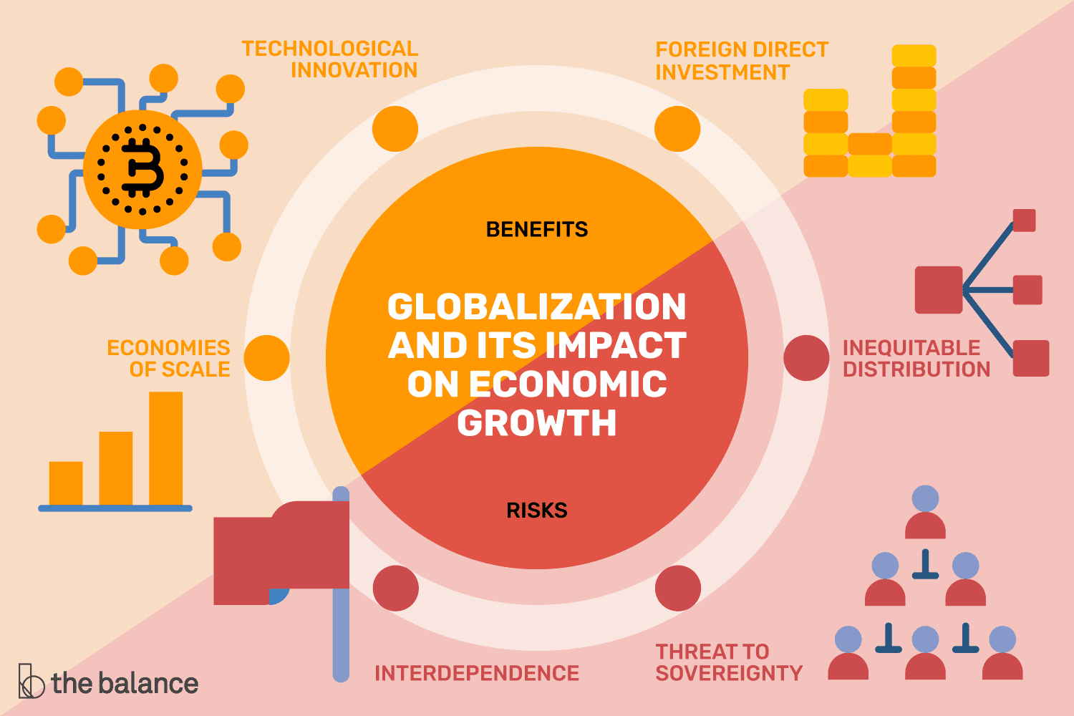
In other words, there is an interconnection between economy, politics and culture that have shaped globalization as we know. You can take a look at the following image that complement some of the ideas that you watched in the previous video.

Throughout the years there have be many who have questioned this system, yet there are no big changes in the picture. Surfing the media, you can find many and more references to globalization as the followings:
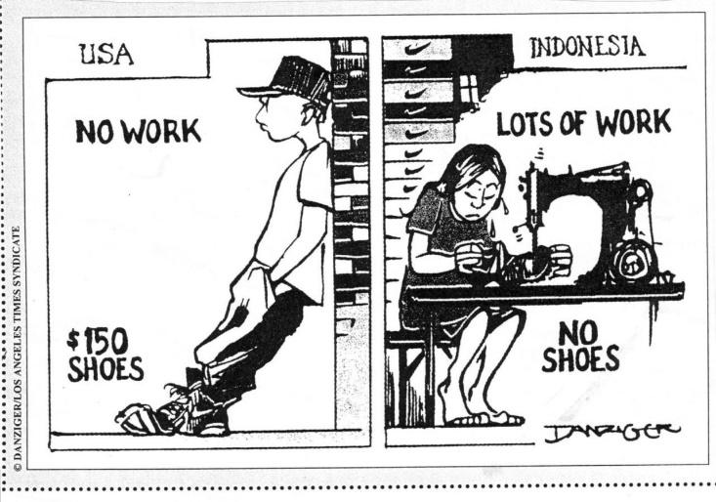
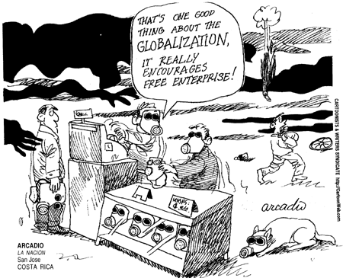

Globalization have impacted us all for a long time, yet there is much to discuss within the concept, as there are many advantages and disadvantages on its consequences. Is it good? Is it bad? We might no be able to answer these questions, but we can debate about it and we compare and contrast its findings.

ITEM 3: ACVIVITY.
You will have to create a leaflet. You can use:
- Publisher (Microsoft)
- Word (brochure template, or https://ask.plcscotch.wa.edu.au/faq/159733)
- Bannersnack (You can create 10 banners for free https://app.bannersnack.com/ )
- Canva (lots of free contents to create https://www.canva.com/)
- If you are working in your smartphone, you can check this apps https://freeappsforme.com/cool-apps-to-create-brochures/
- If you know any other software, webpage or app to create banners/flyers/brochures/leaflets, feel free to use it.

Instructions:
You will have to create a leaflet about how globalization have affected the way we live, you can work on the advantages, disadvantages or both, you can also take ideas from the prompts provided below. The idea is that you create a six-face leaflet that depicts the most important aspects of globalization in our times. There are many possibilities to choose.

As you may know, to create a leaflet/brochure you have to organize your ideas in a logical way, it is recommended to go from general information to specific information, try to pinpoint your ideas before creating the actual thing.

You can guide your work with the following prompts and questions:
(DO NOT CHOOSE MORE THAN ONE TOPIC)
- What is globalization? (you can synthetize your ideas and findings of globalization)
- What are the advantages of globalization?
- What are the disadvantages of globalization?
- Compare and contrast the advantages and disadvantages of globalization.
- How have globalization impacted economy?
- How have globalization impacted the environment?
- What is the impact of globalization? (a general overview of the impact of globalization)
- What are the consequences of globalization?
- Compare and contrast the before and after of globalization.
- Analyse the most controversial findings of globalization.

Your work should look something like this: 🡻
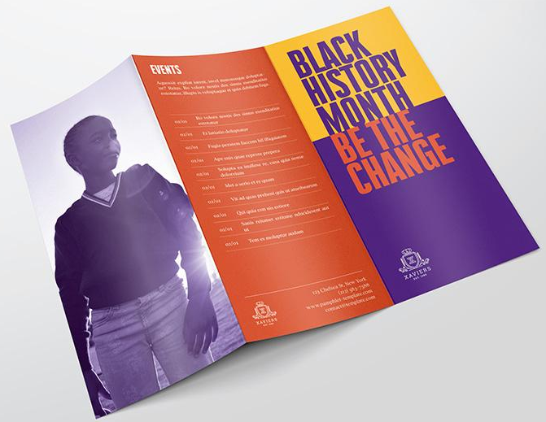
Considerations:
- All 6 faces must have information.
- Add a cover in one of the 6 faces (front page, works as an introduction)
- You must combine text and imagines.
- Organize your information from general to specific.
- You cannot repeat information.
- you cannot write in Spanish or any other language that is not English.
- You must use formal language.
- It has to be digital.
- Do not write your personal information in any of the 6 faces of your work (I will know it is your work by your email and the name of the file/document/picture).
- Do not add huge pictures, try to make it even (as much images as text).
- Do not use all of the suggestions written above, organize your work by picking one.
PAUTA DE EVALUACIÓN “ELABORACIÓN DE TRÍPTICO”

Indicadores de evaluación | Niveles de logro
 | Logrado  5 PUNTOS | Parcialmente logrado  3 PUNTOS | Por lograr  1 PUNTO
- Presenta una portada con un tema claro y definido.
- Presenta la información de manera organizada, partiendo de lo general a lo específico.
- Los “paneles/caras” se presentan de una manera interconectada entre sí. Existe coherencia y cohesión en la información presentada.
- Presenta una relación armónica entre imágenes y texto.
- Demuestra una capacidad en la síntesis de sus ideas al crear frases u organizar información de manera original con sus propias palabras, o extrayendo ideas del video o bien utilizando sus conocimientos previos.
- Cumple con el formato establecido en las instrucciones.
- Presenta ideas claras, un buen uso de vocabulario y una buena redacción en sus ideas.
- Envía su presentación en el plazo establecido
(12-05-2020)
- Realiza correctamente la autoevaluación de la guía nº3

Observaciones:

